Webpage Name- financial courses for students
Website: https://www.mudralaya.com/financial-courses-for-students/
Financial Courses for Students | Best Financial Courses for Students Online
Master Money Skills Before Life Throws Real Bills at You
Financial Courses for Students – because knowing how to manage ₹500 pocket money today can save you from ₹50,000 debt tomorrow.
In today's fast world, students face money decisions early: UPI splurges, education loans, first internships, side gigs, and that tempting credit card offer. Without solid basics, it's easy to slip into stress. That's where financial courses for students step in – practical, beginner-friendly online programs built specifically for young learners in India.

Why Every Student Needs Financial Education Now
Starting early gives massive advantages:
- Build smart habits while expenses are still low
- Avoid common traps like impulse buying or high-interest debt
- Learn to grow small savings through simple investments
- Gain confidence for salary talks, EMIs, and future planning
- Stand out in job interviews with real-world money knowledge
Whether you're in college, preparing for placements, or juggling part-time work, these skills turn financial anxiety into control.
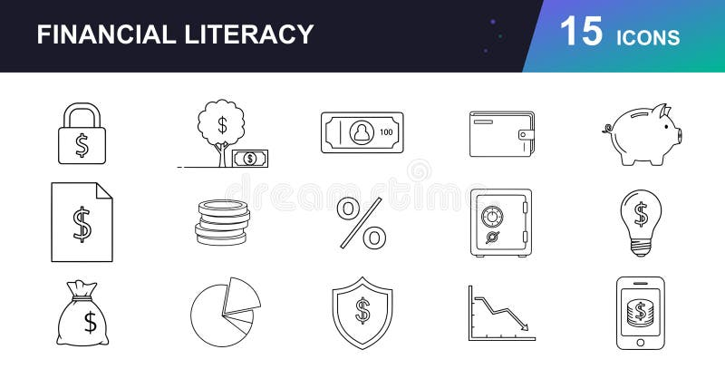
Flexible, Student-Friendly Learning
- 100% online – learn from hostel, café, or home
- Self-paced – fit around classes, exams, and hangouts
- Short modules (15–40 mins) with videos, quizzes, and real examples
- Mobile-friendly – study on phone during commutes
- Certificates included – add to LinkedIn or resume
- Affordable pricing – designed for student budgets
No prior knowledge needed. Start from basics and progress at your speed.

Take the First Step Toward Financial Freedom
Don't wait for your first job to learn money management. Equip yourself now with the best financial courses for students online – practical knowledge that pays off for decades.

